# Slide 1

Salesforce — Phase 2: Step-by-Step Guide

# Slide 2

Login to Salesforce

Step 1: Open Salesforce login page.  
Step 2: Enter Username and Password.  
Step 3: Click Login.

# Slide 3

Navigate to Setup

Step 1: Click on the gear icon (⚙).  
Step 2: Select 'Setup'.

# Slide 4

Company Information

Step 1: In Quick Find, type 'Company Information'.  
Step 2: Open Company Information settings.  
Step 3: Review and edit Organization details.

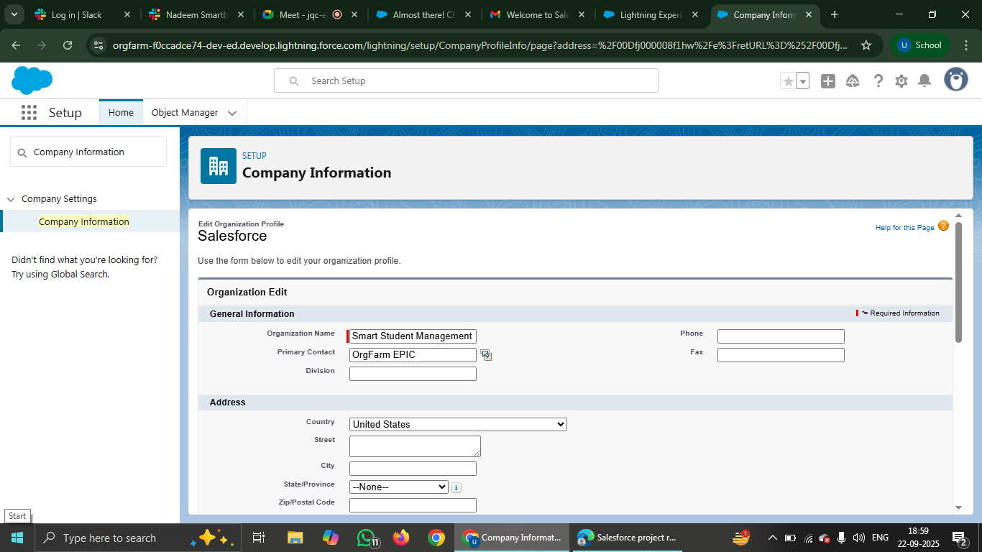

# Slide 5

Edit Company Information

Step 1: Click 'Edit' button.  
Step 2: Update Name, Address, Locale.  
Step 3: Save changes.

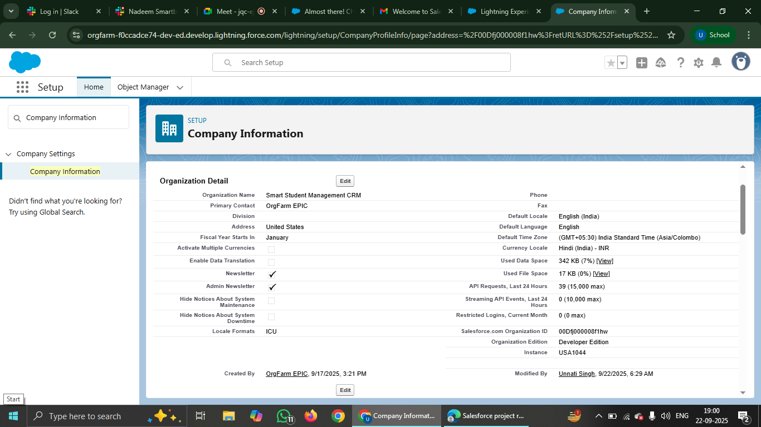

# Slide 6

Fiscal Year Settings

Step 1: In Setup, search 'Fiscal Year'.  
Step 2: Choose Standard or Custom fiscal year.  
Step 3: Configure year start and end dates.

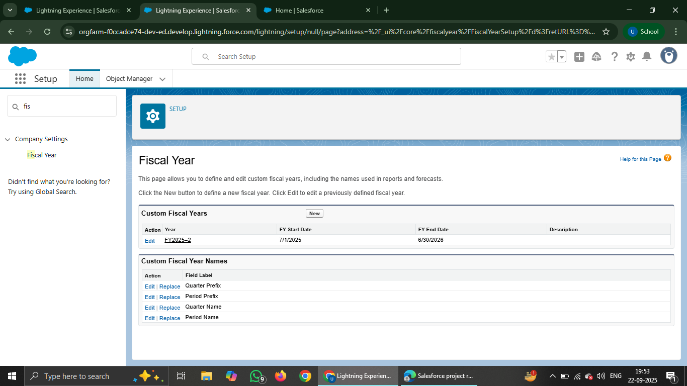

# Slide 7

Business Hours

Step 1: In Setup, search 'Business Hours'.  
Step 2: Create or edit business hours.  
Step 3: Define working days and times.

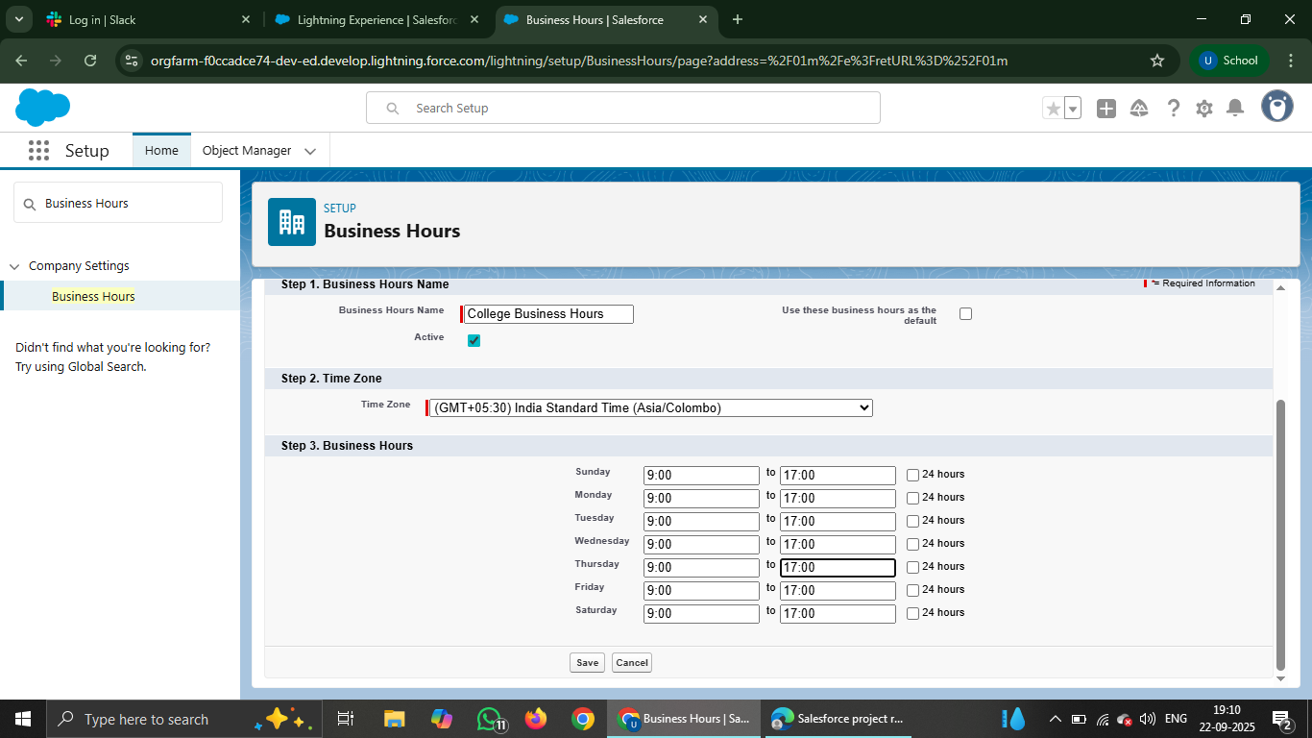

# Slide 8

Add Business Hours

Step 1: Click 'New Business Hours'.  
Step 2: Enter Name, Timezone.  
Step 3: Set open and close hours.  
Step 4: Save.

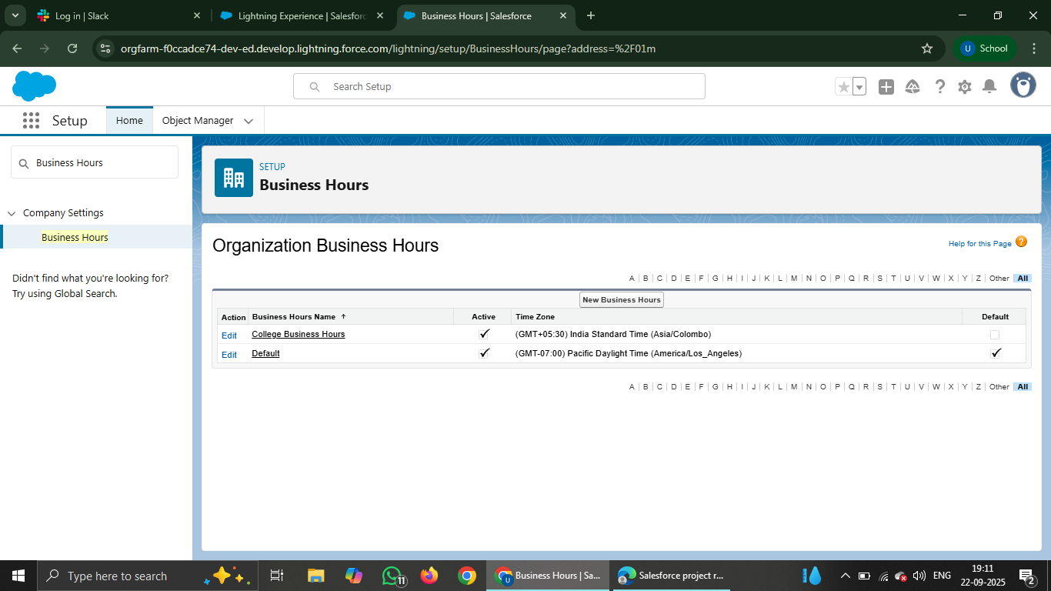

# Slide 9

Holidays

Step 1: In Setup, search 'Holidays'.  
Step 2: Click 'New'.  
Step 3: Add holiday name, date range.  
Step 4: Save.

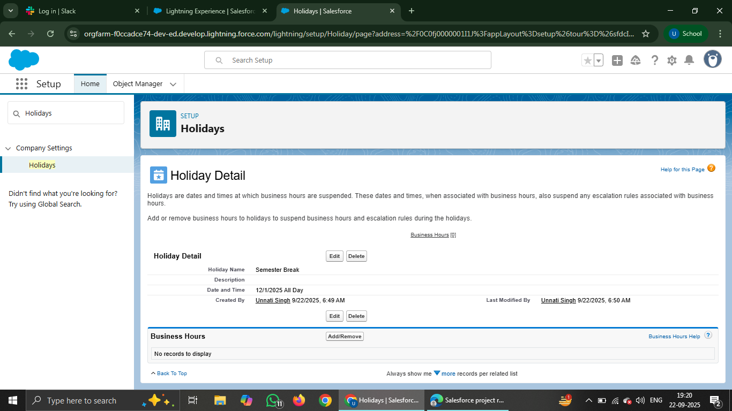

# Slide 10

PROFILES

Step 1: In Setup, search 'Profiles'.  
Step 2: Open an existing profile.  
Step 3: Edit permissions and settings.

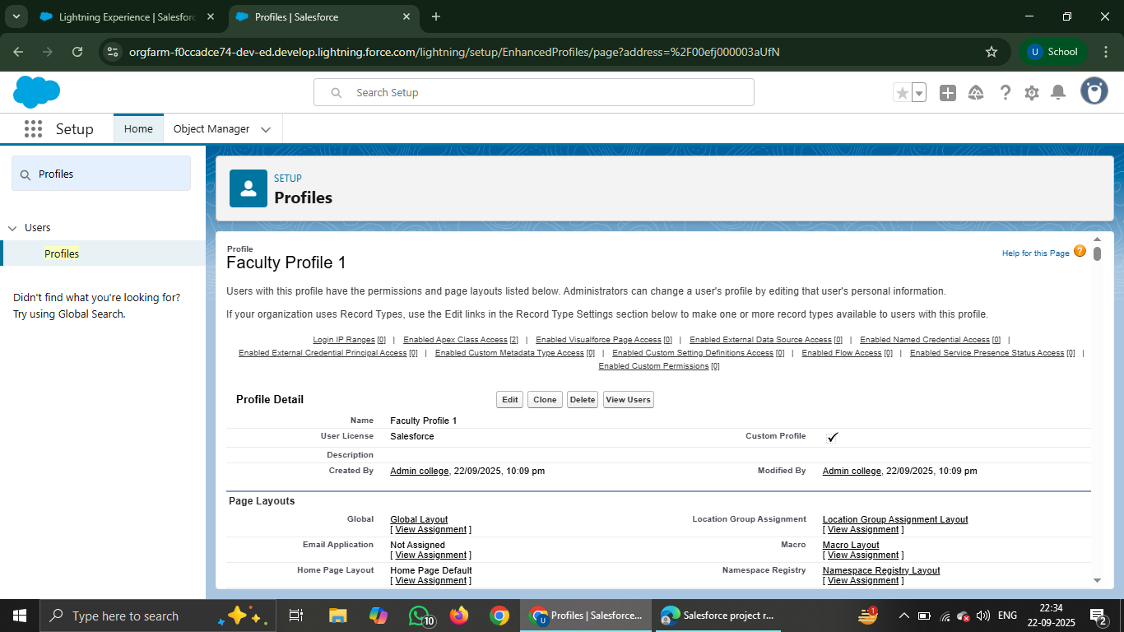

# Slide 11

Clone Profile

Step 1: Select a profile to clone.  
Step 2: Click 'Clone'.  
Step 3: Enter new profile name.  
Step 4: Save.

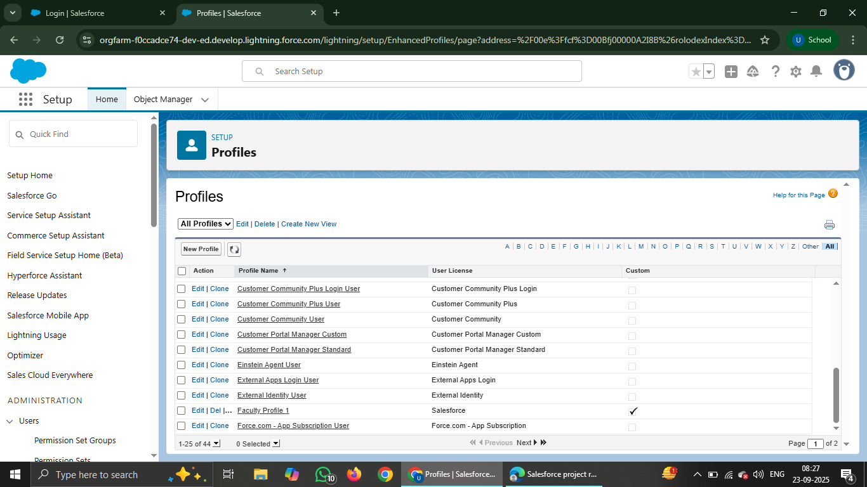

# Slide 12

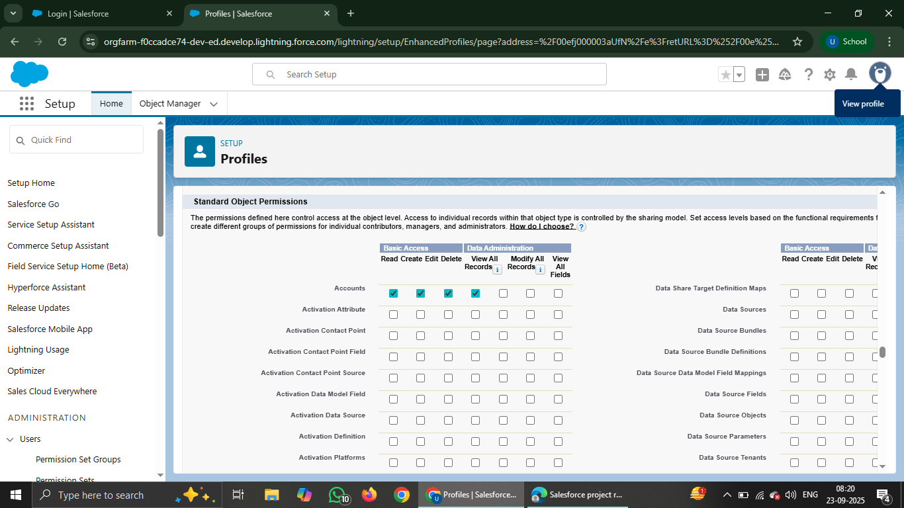

# Slide 13

User Management

Step 1: In Setup, search 'Users'.  
Step 2: Click 'New User'.  
Step 3: Enter user details.

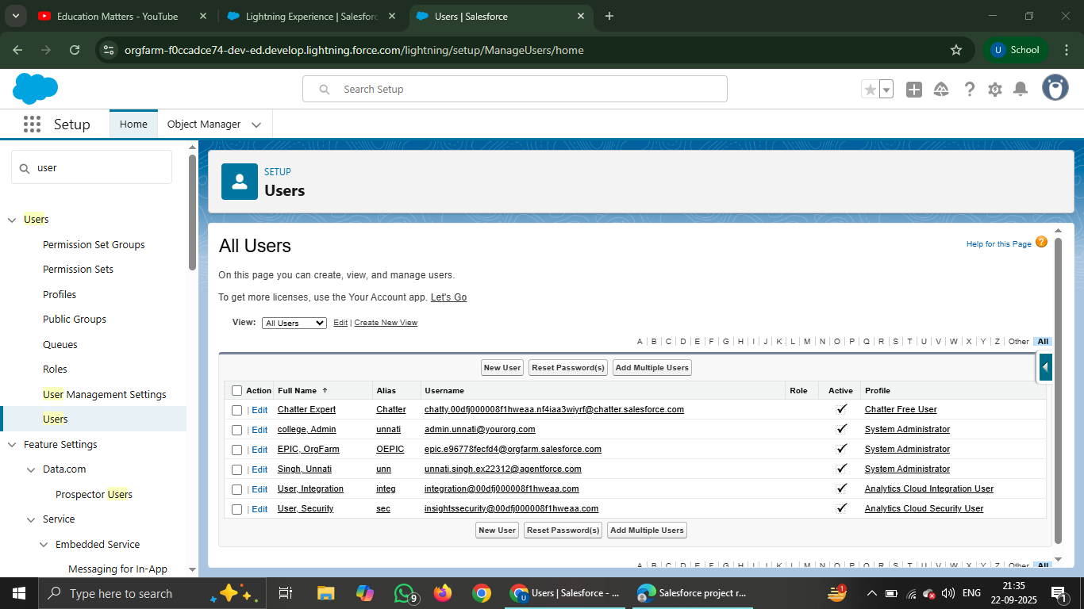

# Slide 14

Create New User

Step 1: Fill First Name, Last Name, Email.  
Step 2: Assign Username, Profile, Role.  
Step 3: Select License.  
Step 4: Save and send activation email.

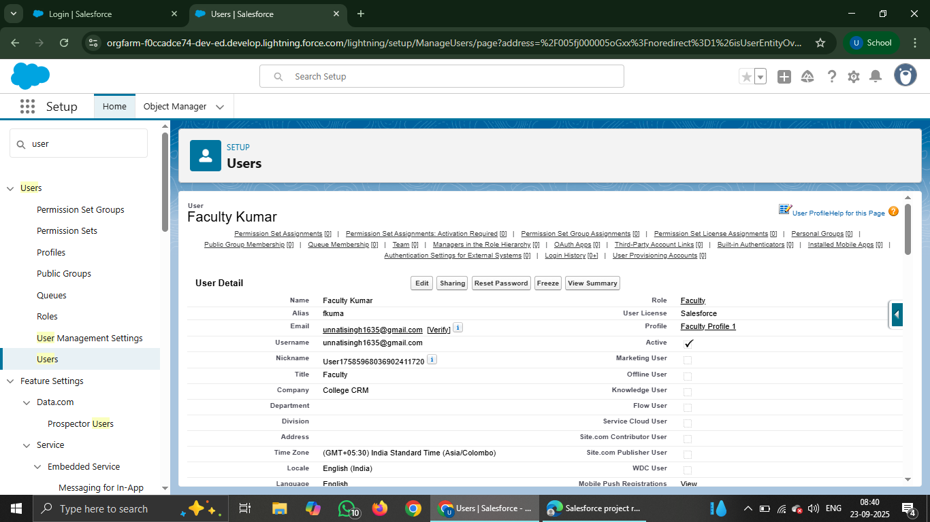

# Slide 15

Deactivate User

Step 1: Go to Users list.  
Step 2: Select the user.  
Step 3: Uncheck 'Active'.  
Step 4: Save.

# Slide 16

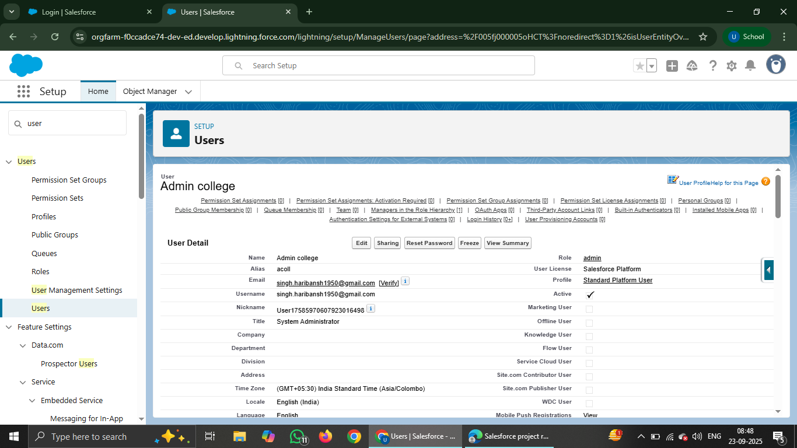

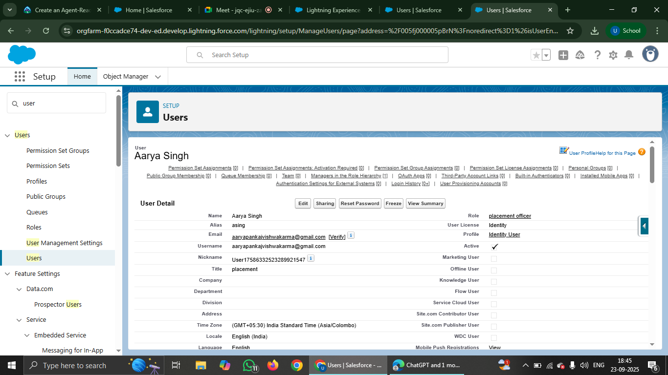

# Slide 17

Roles

Step 1: In Setup, search 'Roles'.  
Step 2: Click 'Set Up Roles'.  
Step 3: View role hierarchy.

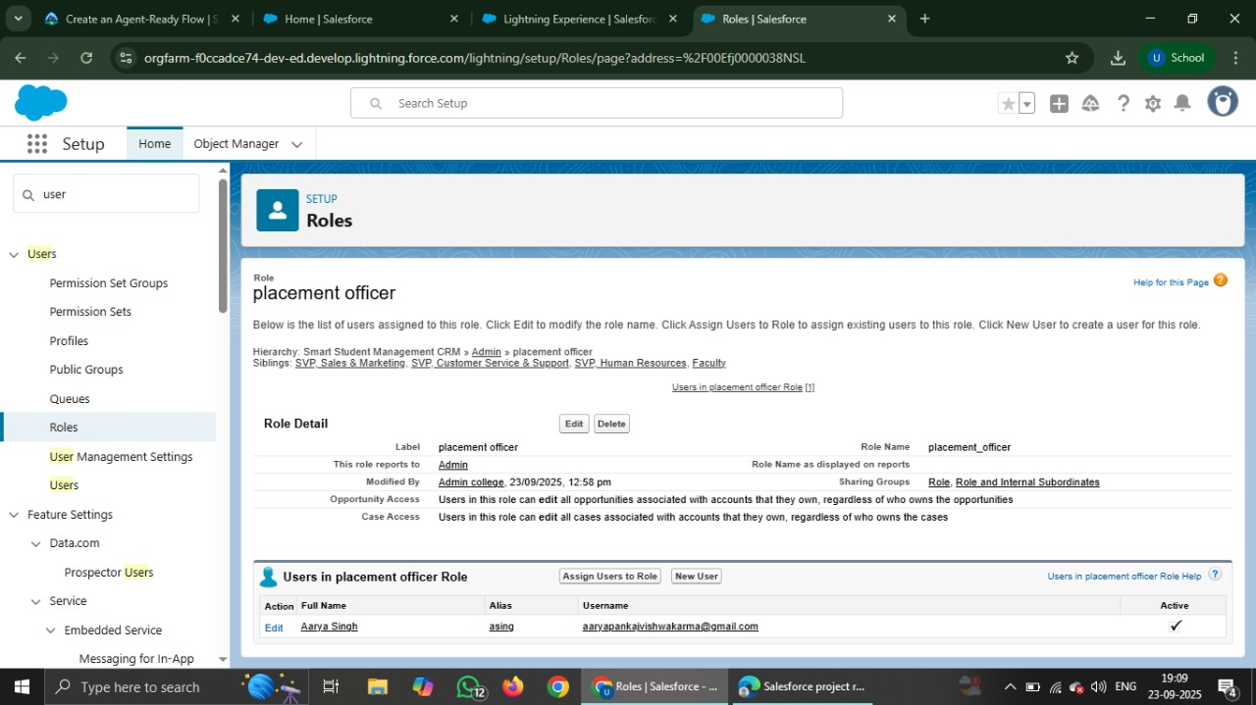

# Slide 18

Create a Role

Step 1: Click 'Add Role'.  
Step 2: Enter role name and description.  
Step 3: Assign parent role if required.  
Step 4: Save.

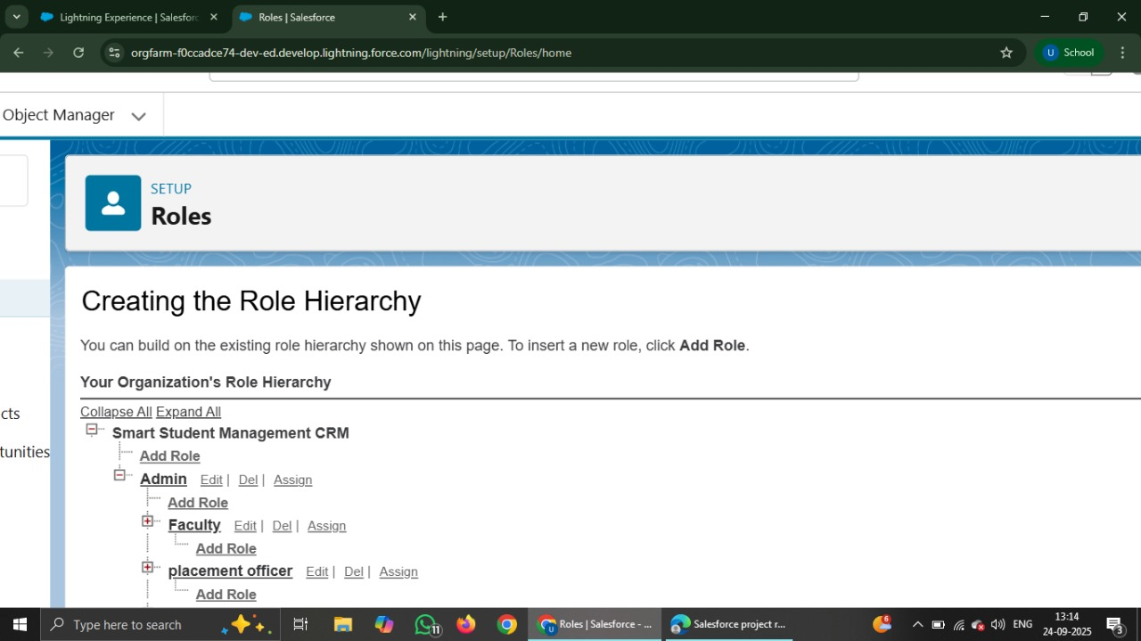

# Slide 19

Assign Users to Role

Step 1: Open Role details page.  
Step 2: Click 'Assign Users to Role'.  
Step 3: Select and assign users.

# Slide 20

Permission Sets

Step 1: In Setup, search 'Permission Sets'.  
Step 2: Create a new permission set.  
Step 3: Add specific permissions.

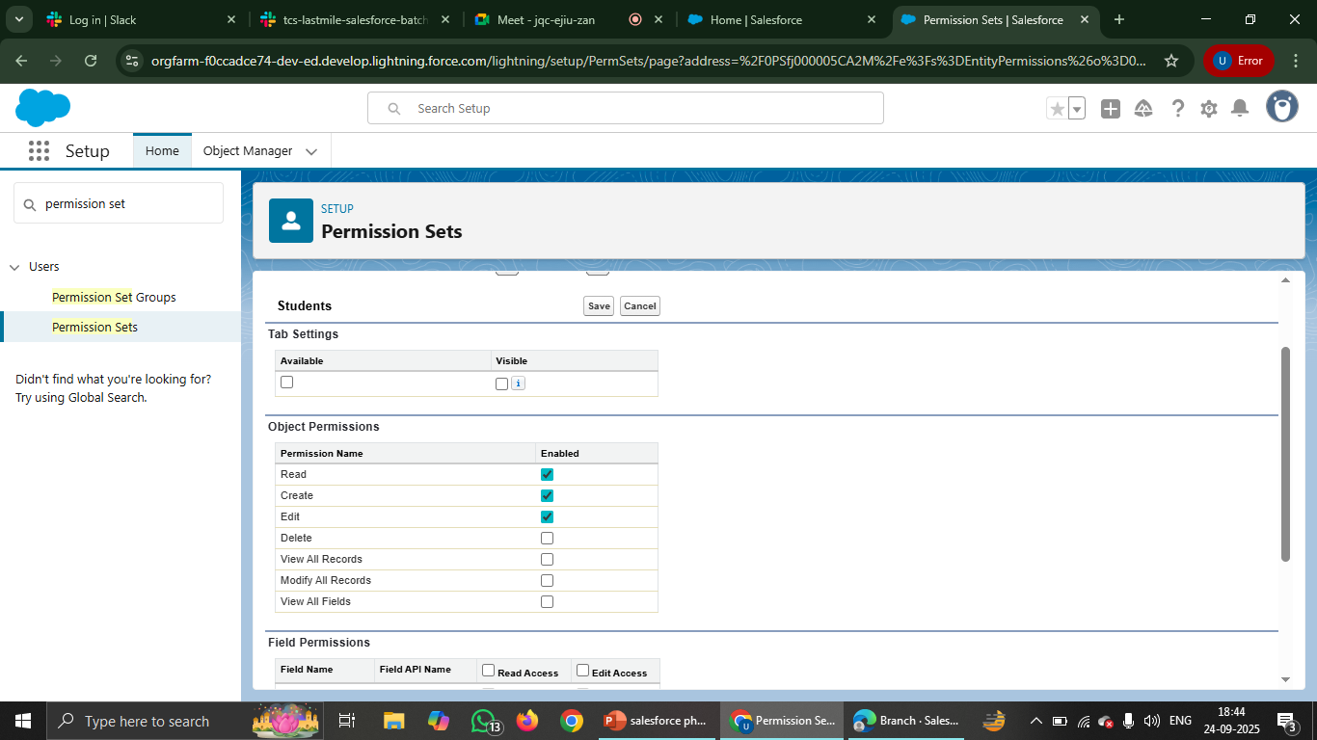

# Slide 21

Assign Permission Set

Step 1: Open the Permission Set.  
Step 2: Click 'Manage Assignments'.  
Step 3: Assign to users.

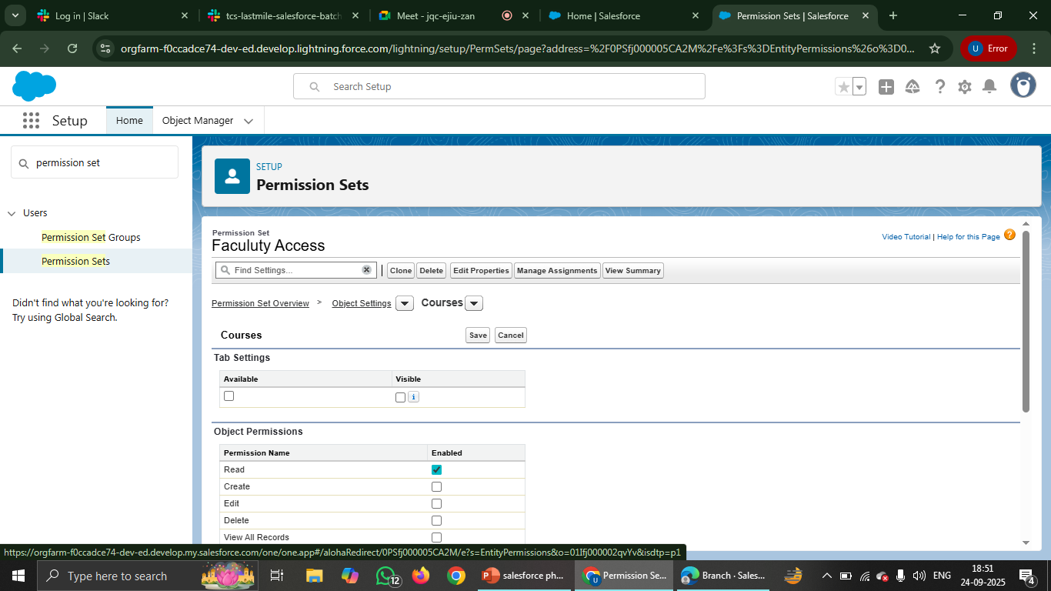

# Slide 22

Organization-Wide Defaults

Step 1: In Setup, search 'Sharing Settings'.  
Step 2: Edit OWD for each object.  
Step 3: Save changes.

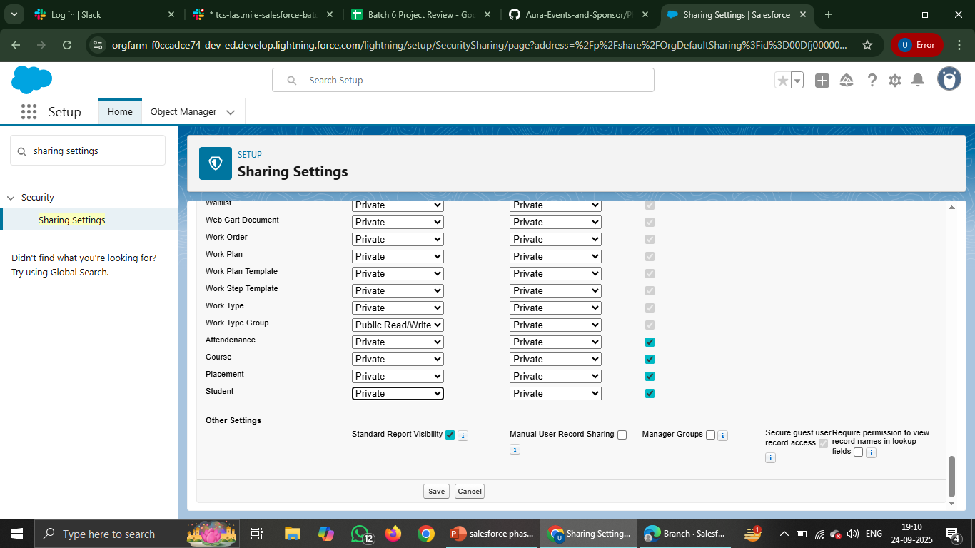

# Slide 23

Sharing Rules

Step 1: In Setup, search 'Sharing Rules'.  
Step 2: Create new sharing rule.  
Step 3: Define criteria and target roles/users.

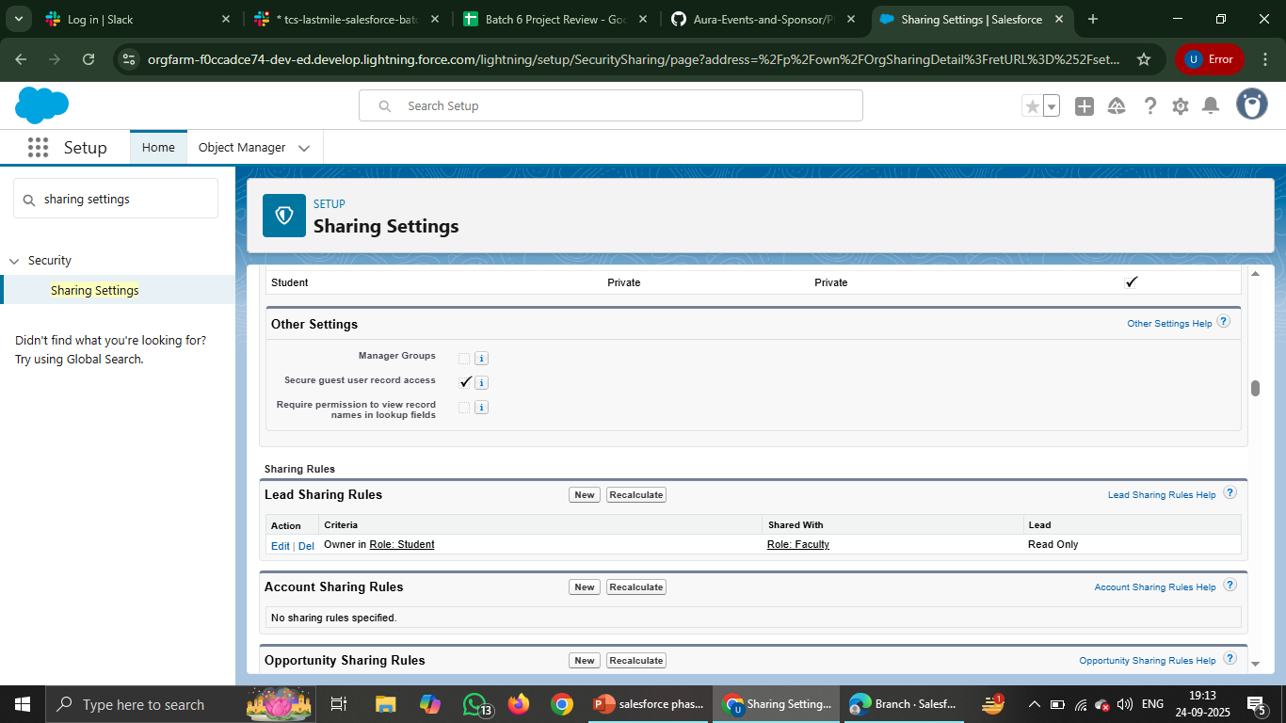

# Slide 24

Testing User Access

Step 1: Login as a test user.  
Step 2: Verify permissions (create, edit, delete).  
Step 3: Adjust if issues occur.

